**User Stories**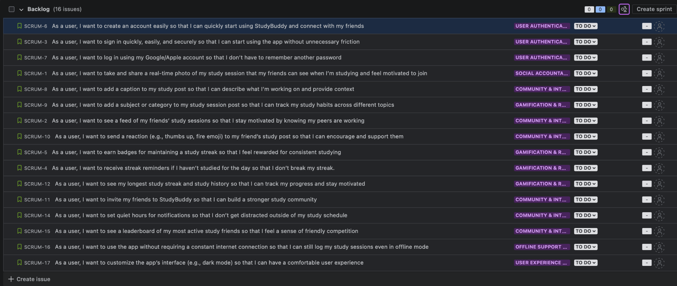

Changelog:

* “Study Photo” changed to be more descriptive
* Cut off of “offline mode” resolved